**Khoo Ju Seng Bryant U1420978E**

**Data Exploration**

The aim of doing Data Exploration is to understand the given dataset, and compare the data to the business problem. I will using the following questions as the guidelines for Data exploration

1. Is the data sufficient?

* Firstly, run the summary function.
  + There are NA values in dvc and ib as shown below.

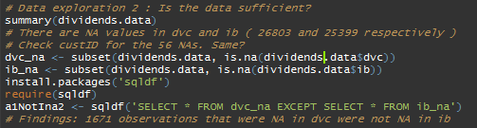

Fig. 1

* Using a package called ‘sqldf’, I was able to run a command that resembles sql’s select function to find out how many rows were NA in dvc but not in NA. The findings can be seen in Figure 1.

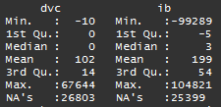

Fig 2. NA values for dvc and ib

1. Does the data provide predictive value?

* I used ggplot 2 to plot a scatter plot with a smooth line, to see the general datapoints and relationship between the two columns.

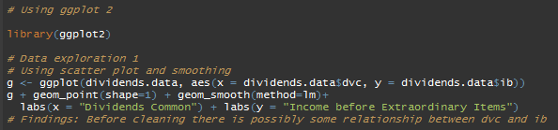

Fig. 3 Using gg plot

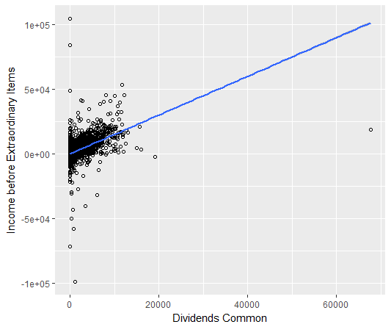

Fig 4. Scatter plot of ib against dvc

* Findings: before data cleaning, we can already see that there **is possibly** a relationship between dvc and ib. **However, there are still outliers.**

1. How is the data quality and are there any anomalies?

* After doing summary(), I noticed that there were negative dvc values.
* I did the following to find out how many rows were negative.

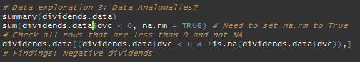

* Findings: there were 15 negative rows.

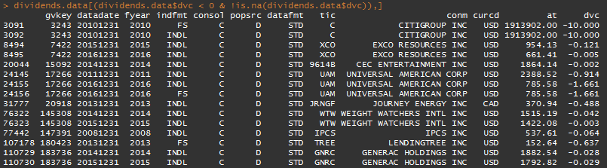

**Data Cleaning**

**2a.**

Running the following r script to obtain subset, by only limiting exchg = 11, 12 and 14, we have 70161 rows left.

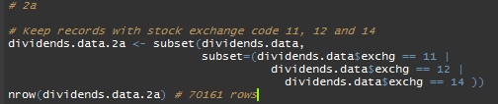

**2b.**

After limiting to only USD, we have 68,876 rows left.

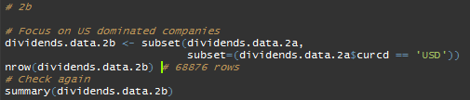

**2c.**

After only focusing on sic within the given ranges, we have 30001 rows left.

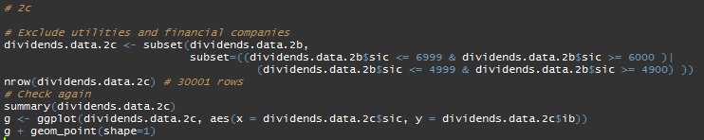

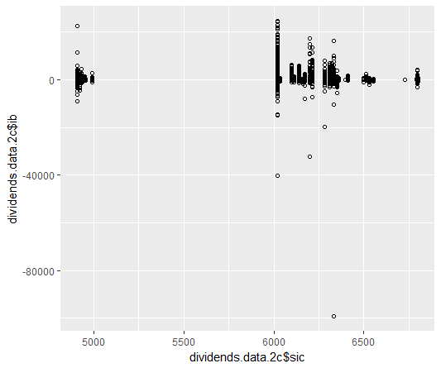

Fig 5. Scatter plot to double confirm the ranges are correct

**2d.**

After removing rows that do not have ib, we have 22159 rows left.

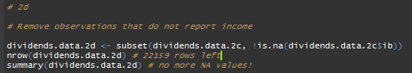

**2 e.**



Fig 6. Expert opinion

Based on the above opinion that there should not be negative dividends, I decided to remove all NA and negative values for dvc.

Also I remove na values for **at, ib, idit, spi, xint and costat** since these are the variables that I feel have value or is relevant to our business problem.

After running the r script below, there is 13,252 rows left.

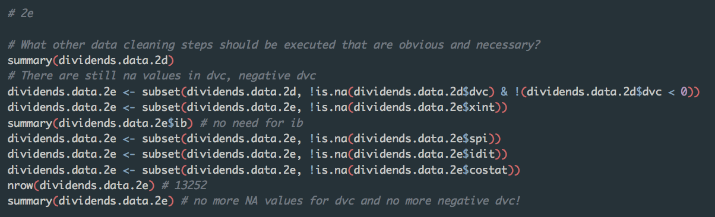

**4.**

**Variable Selection**

The leaps package was used to invoke regsubsets() to find the best subset of variables

I’ve chosen 7 variables to include in m.full, and only those that made sense to me that they should or might have an impact on dividends. They are at, dvc, ib, idit, prstkc, spi, xint and costat.

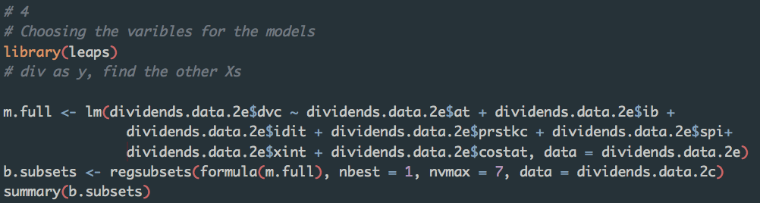

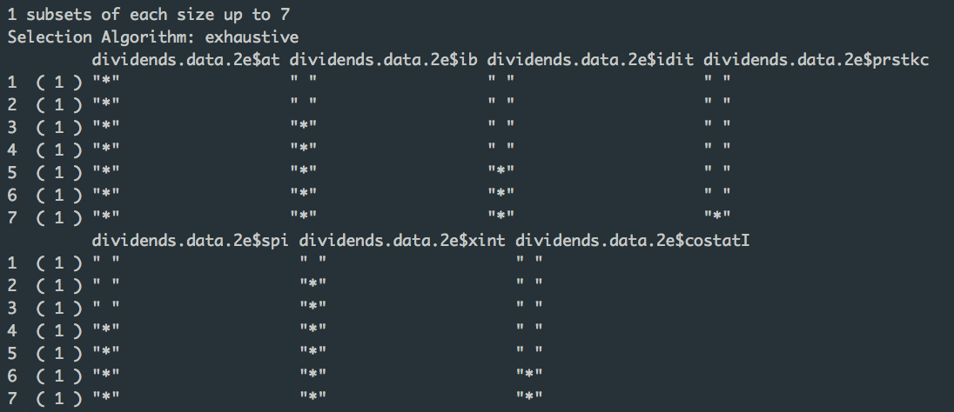

In the end, I decided to choose a model based on the best subset with lowest BIC.

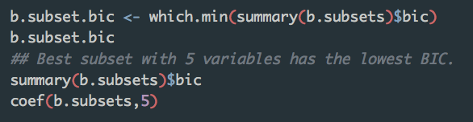

I got the following coefficients

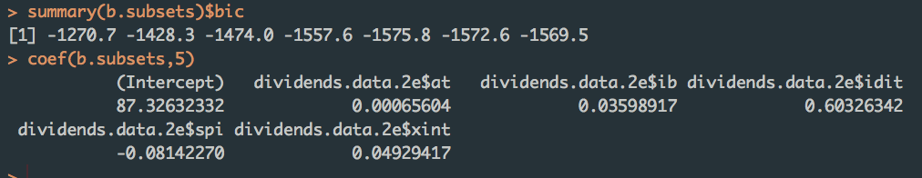

Thus, I will use at, ib, idit, spi and xint as my variables for the following models.

**4a. Linear Regression**

Firstly split train test set:

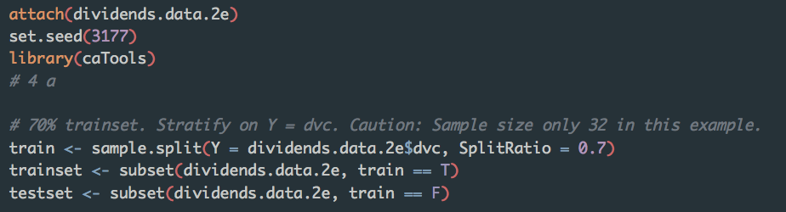

Next, run model on train set.

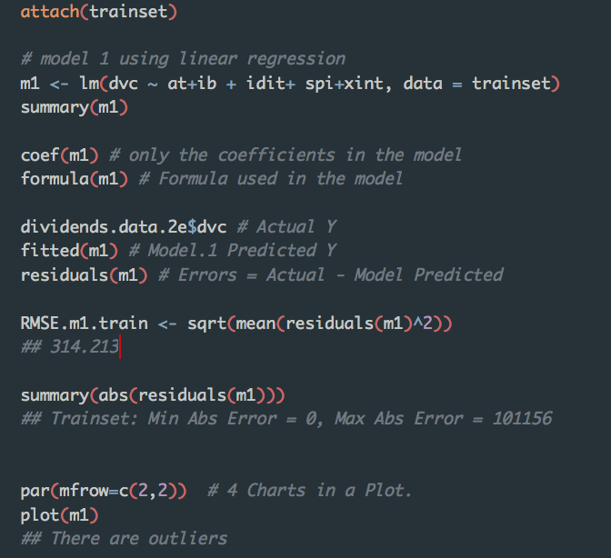

RMSE is 314.213 on the trainset.

Next I run it with the test set:

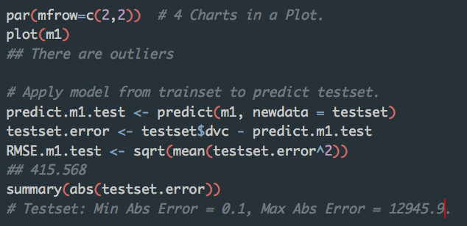

RMSE value is 415.568 on the test set. It has increased by around 100. This **could** be a result of overfitting.

Results of lm()

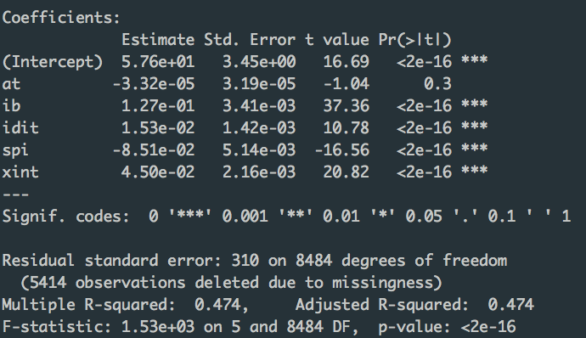

* Ib, idit, spi and xint are very significant according to p-values!

Coefficients of the model:

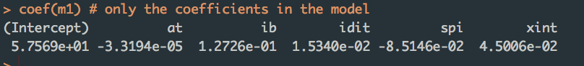

RMSE of train set is 309.742.

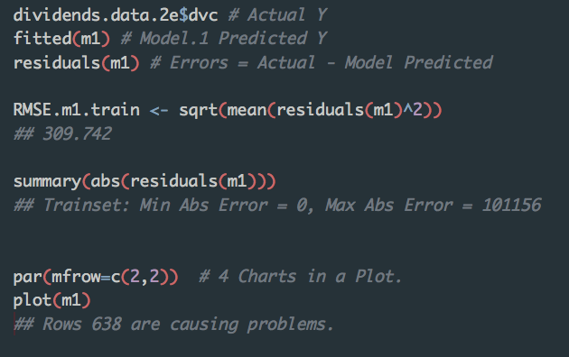

Upon plotting diagnostic plots:



* Based on cook’s distance there are still certain influential outliers.

**4b Logistic Regression**

* First, I discretized dvc so that I can conduct logistics regression for a categorical Y.
* I split dvc into 2 breaks, with the 2nd break starting from 0.001.
* This is to split all the dvc == 0 observations from the rest with positive dvc.

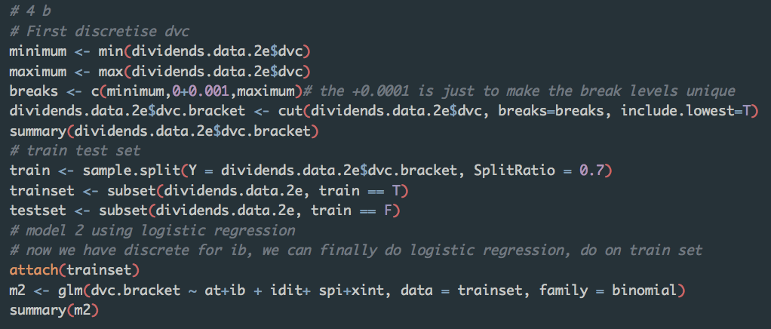

Running glm() on train set, I get the following results:

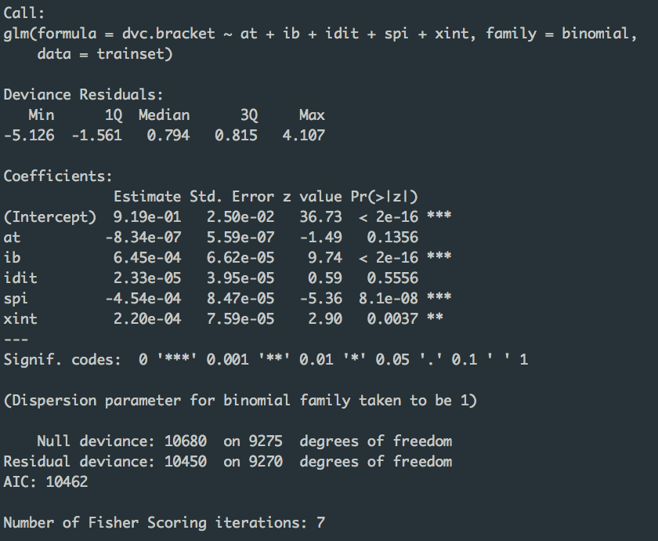

Next, I run the confusion matrix on the trainset:

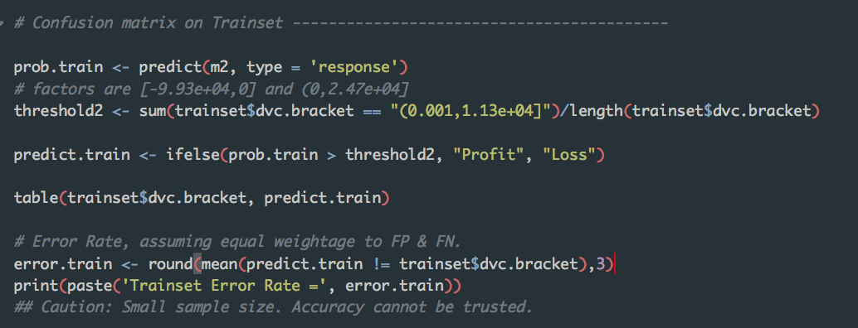

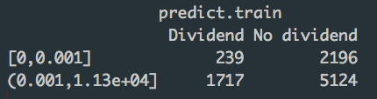

* There were 5124 false negatives and 239 false positives.
* Misclassification rate is very high for this logistic regression model! I was unable to finish checking due to time constraints.
* **There will be a need to double check on this model in the future.**

**Running on test set, to obtain confusion matrix:**

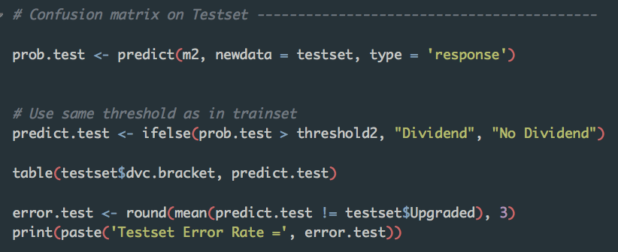

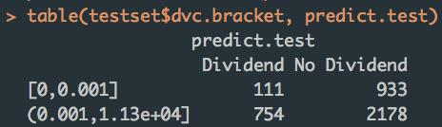

* There were 2178 false negatives and 111 false positives.
* Misclassification rate is very high for this logistic regression model! I was unable to finish checking due to time constraints.
* **There will be a need to double check on this model in the future.**

**4c Decision Tree**

With the same variables as before, I grow the tree to max initially with cp =0.

* However, I set the minsplit to be 500 since there are 13252 observations in total. It would be unrealistic to put a small minsplit value

I ran the following R script:

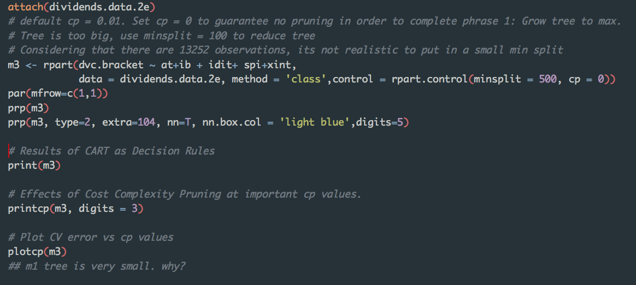

results from printcp() are:

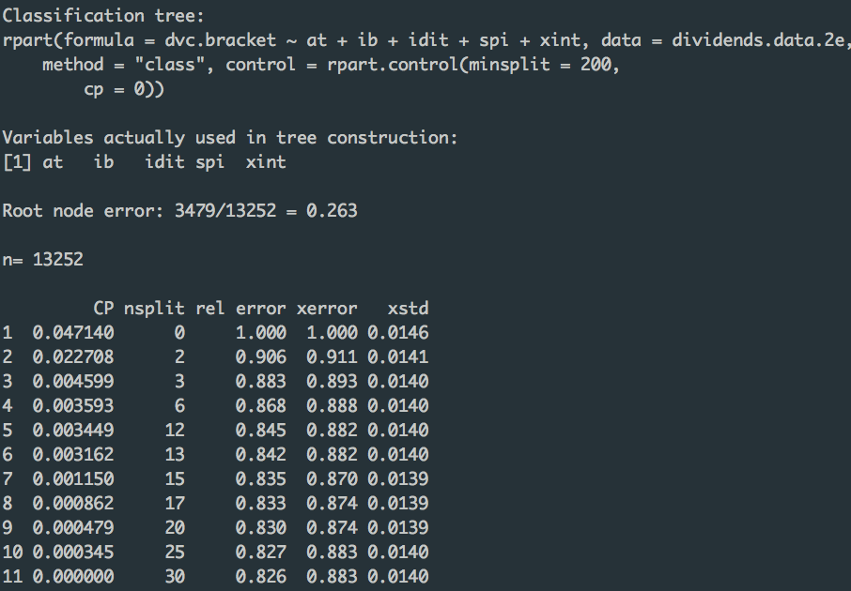

Results from print(m3) are:

> print(m3)

n= 13252

node), split, n, loss, yval, (yprob)

* denotes terminal node

1) root 13252 3479 (0.001,1.13e+04] (0.26253 0.73747)

2) ib< 3.7425 3986 1841 (0.001,1.13e+04] (0.46187 0.53813)

4) xint< 6.0215 1492 582 [0,0.001] (0.60992 0.39008)

8) ib< 1.64 1119 356 [0,0.001] (0.68186 0.31814)

16) idit>=0.0065 632 144 [0,0.001] (0.77215 0.22785) *

17) idit< 0.0065 487 212 [0,0.001] (0.56468 0.43532)

34) at< 112.21 207 56 [0,0.001] (0.72947 0.27053) *

35) at>=112.21 280 124 (0.001,1.13e+04] (0.44286 0.55714)

70) xint< 0.4875 93 37 [0,0.001] (0.60215 0.39785) *

71) xint>=0.4875 187 68 (0.001,1.13e+04] (0.36364 0.63636) *

9) ib>=1.64 373 147 (0.001,1.13e+04] (0.39410 0.60590)

18) idit>=20.773 84 36 [0,0.001] (0.57143 0.42857) *

19) idit< 20.773 289 99 (0.001,1.13e+04] (0.34256 0.65744) *

5) xint>=6.0215 2494 931 (0.001,1.13e+04] (0.37330 0.62670)

10) idit>=0.0795 1575 679 (0.001,1.13e+04] (0.43111 0.56889)

20) ib< 1.4425 1245 571 (0.001,1.13e+04] (0.45863 0.54137)

40) idit< 108.05 921 456 [0,0.001] (0.50489 0.49511)

80) xint< 21.306 460 205 [0,0.001] (0.55435 0.44565)

160) ib< -8.1835 160 51 [0,0.001] (0.68125 0.31875) *

161) ib>=-8.1835 300 146 (0.001,1.13e+04] (0.48667 0.51333)

322) xint< 9.7945 134 60 [0,0.001] (0.55224 0.44776) *

323) xint>=9.7945 166 72 (0.001,1.13e+04] (0.43373 0.56627) *

81) xint>=21.306 461 210 (0.001,1.13e+04] (0.45553 0.54447)

162) ib< -130.88 86 34 [0,0.001] (0.60465 0.39535) *

163) ib>=-130.88 375 158 (0.001,1.13e+04] (0.42133 0.57867)

326) at< 1095.1 87 37 [0,0.001] (0.57471 0.42529) *

327) at>=1095.1 288 108 (0.001,1.13e+04] (0.37500 0.62500) *

41) idit>=108.05 324 106 (0.001,1.13e+04] (0.32716 0.67284) *

21) ib>=1.4425 330 108 (0.001,1.13e+04] (0.32727 0.67273) *

11) idit< 0.0795 919 252 (0.001,1.13e+04] (0.27421 0.72579)

22) ib< -14.907 551 179 (0.001,1.13e+04] (0.32486 0.67514)

44) at< 885.72 74 33 [0,0.001] (0.55405 0.44595) *

45) at>=885.72 477 138 (0.001,1.13e+04] (0.28931 0.71069) *

23) ib>=-14.907 368 73 (0.001,1.13e+04] (0.19837 0.80163) *

3) ib>=3.7425 9266 1638 (0.001,1.13e+04] (0.17678 0.82322)

6) xint< 39.116 5089 1168 (0.001,1.13e+04] (0.22951 0.77049)

12) spi>=1.963 364 136 (0.001,1.13e+04] (0.37363 0.62637)

24) at< 679.93 87 39 [0,0.001] (0.55172 0.44828) *

25) at>=679.93 277 88 (0.001,1.13e+04] (0.31769 0.68231) *

13) spi< 1.963 4725 1032 (0.001,1.13e+04] (0.21841 0.78159)

26) at< 3168.8 3877 915 (0.001,1.13e+04] (0.23601 0.76399)

52) spi< -1.4705 584 217 (0.001,1.13e+04] (0.37158 0.62842)

104) at< 422.11 67 31 [0,0.001] (0.53731 0.46269) *

105) at>=422.11 517 181 (0.001,1.13e+04] (0.35010 0.64990)

210) ib>=23.817 261 111 (0.001,1.13e+04) (0.42529 0.57471)

420) xint>=12.014 128 61 [0,0.001] (0.52344 0.47656) *

421) xint< 12.014 133 44 (0.001,1.13e+04] (0.33083 0.66917) *

211) ib< 23.817 256 70 (0.001,1.13e+04] (0.27344 0.72656) *

53) spi>=-1.4705 3293 698 (0.001,1.13e+04] (0.21196 0.78804)

106) xint< 12.343 2251 538 (0.001,1.13e+04] (0.23900 0.76100)

212) at>=13.624 2181 538 (0.001,1.13e+04] (0.24668 0.75332)

424) xint< 1.3475 542 173 (0.001,1.13e+04] (0.31919 0.68081)

848) ib< 35.506 370 141 (0.001,1.13e+04] (0.38108 0.61892)

1696) at>=594.19 76 35 [0,0.001] (0.53947 0.46053) *

1697) at< 594.19 294 100 (0.001,1.13e+04] (0.34014 0.65986) *

849) ib>=35.506 172 32 (0.001,1.13e+04] (0.18605 0.81395) *

425) xint>=1.3475 1639 365 (0.001,1.13e+04] (0.22270 0.77730) *

213) at< 13.624 70 0 (0.001,1.13e+04] (0.00000 1.00000) *

107) xint>=12.343 1042 160 (0.001,1.13e+04] (0.15355 0.84645) *

27) at>=3168.8 848 117 (0.001,1.13e+04) (0.13797 0.86203) *

7) xint>=39.116 4177 470 (0.001,1.13e+04) (0.11252 0.88748) *

prp() returned me the following plotted tree:



Plotting cp:



* Note: I increased the minsplit to 500 so that each node needs to have 500 observations. This is to prevent the tree from being too large.

**4d Segregate Data into time frames**

**5.**

To check if the relationship between reporting losses and paying dividends might less strong if the losses are attributable to special items, we will need to check the relationship between income and special items, I did this by checking the correlation:

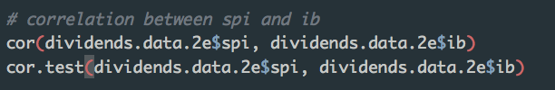

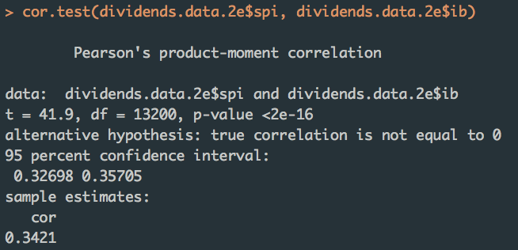

Cor between ib and spi is 0.3421, suggesting the relationship to be not very strong. P-value is well below our level of significance of 0.05.

Also, I plotted a scatterplot to study the relationship

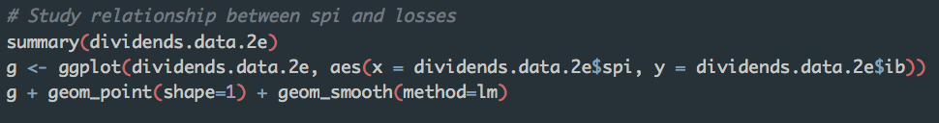



The observations are well spread out, suggesting there to be not a linear relationship.

Next, to see if there is relationship between the independent variables (X): ib and spi, we can do vif(). VIF quantifies how much the variance is inflated and it helps us detect if some Xs are highly correlated with some other Xs (singly or in combination) in the model, resulting in instability.

* Regression coefficients become highly unstable when:

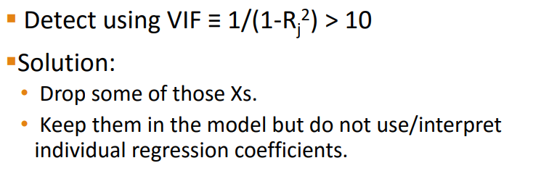

After running vif() we get the following:

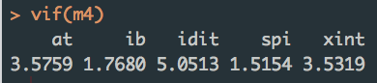

VIF for spi and ib are well below the threshold of 10, and also well below the warning threshold of 4 (decided by expert opinion).

**Conclusion:** Hence, we might have conclusive evidence that relationship between reporting losses and paying dividends might be less strong if losses are attributable to special items.

**6.**

**Models must be statistically significant with p-value less than 5?**

Before understanding p-values, I refer to what we learnt on the null hypothesis in class:

* H0: popln corr = 0
* H1: popln corr =/= 0
* There is mean, sd and corr for both population and sample.
* Population corr is usually unknown. So the question is, what are the chances of popn corr being 0? We will use p-value to find out
* 2 tailed test of whether the popn correlation coeff is zero or not zero.
* The lower the p-value the stronger the evidence to reject Null Hypothesis.
* If < 0.05 by default, we will be rejecting null hypothesis. So, we are saying that popln corr =0 is rejected, there is enough evidence to point towards correlation between the 2 variables.
* Thus, we use p-value to determine if null hypothesis is true. If p less than alpha (level of significance, usually 0.05, we reject null hypothesis)
* **Thus, p-value estimates how well the sample data supports that the null hypothesis is true. It measures how compatible our data is with the null hypothesis.**
* **P-values are mainly used in null hypothesis testing in order to quantify the idea of statistical significance of evidence. It is said that p-values that allow us to reject the null hypothesis are statistically significant.**
* **This is further supported by expert opinion:**
  + <http://www.investopedia.com/terms/s/statistically_significant.asp>

**7.**

**Value of the 1SE rule compared to what we did in 4(c)**

What I found out by quick research on google about 1SE rule:

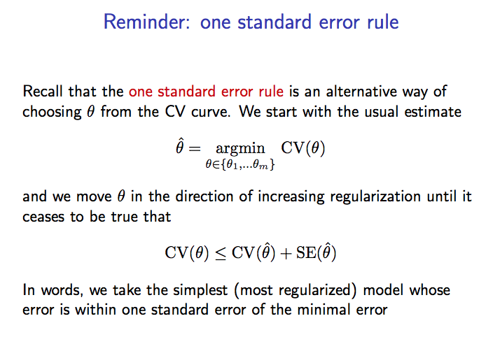

Compared to what we did in 4c, which is using the Gini index to select the splitting variable and split point by minimizing weighted average Gini impurity of the resultant child nodes, the recommendation includes cross validation. The **advantage** of this method over repeated random sub-sampling (see below) is that all observations are used for both training and**validation**, and each observation is used for **validation** exactly once.